3. Requirements Gathering

3.1 Stakeholder Analysis

Identified Stakeholders
- End Users (Non-Technical Users)
  - Individuals receiving suspicious messages (Email, SMS, WhatsApp, Telegram).
  - Needs:
    - Simple and clear verdict (Safe / Suspicious / Scam)
    - No technical complexity
    - Fast results
    - Support for Arabic and English
    - Easy upload or input process
- External Services (e.g., VirusTotal API)
  - Third-party threat intelligence providers.
  - Needs:
    - Proper API integration
    - Controlled and optimized request usage
    - Secure handling of API keys
- System Administrators
  - Responsible for maintaining and monitoring the system.
  - Needs:
    - System monitoring dashboard
    - Logs and alerts
    - Control over storage and data retention
    - Security management (rate limiting, abuse prevention)
- Development Team
  - Engineers building and maintaining the system.
  - Needs:
    - Modular architecture
    - Clear documentation
    - Scalable design
    - Maintainable and testable codebase

3.2 User Stories

User Story 1 – Email Analysis
- As a non-technical user
- I want to upload or paste an email (including headers)
- So that I can know whether it is legitimate or a phishing attempt

User Story 2 – Multi-Channel Scam Detection
- As a non-technical user
- I want to check suspicious messages from WhatsApp, Telegram, SMS, or phone calls
- So that I can verify if they are scams without technical knowledge

3.3 User Stories
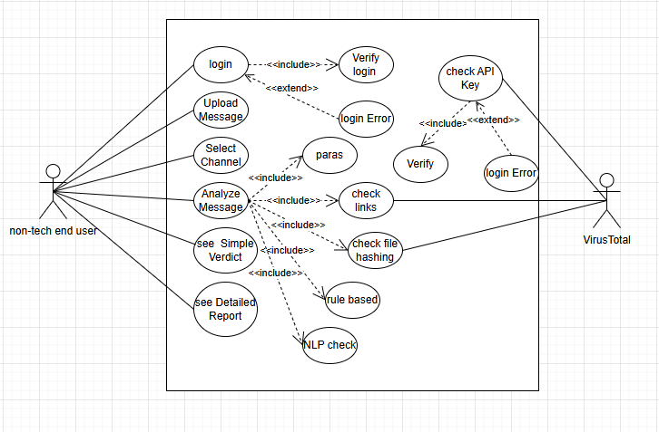

More details https://drive.google.com/file/d/1MrcRybtR3u_zb8zMGGmMjKiIrOhBfusi/view?usp=sharing

3.4 Functional Requirements

Core Features
- Message Input
  - Users can upload or paste messages
  - Support for Email, SMS, WhatsApp, Telegram
- Channel Selection
  - User selects message type before analysis
- Message Parsing
  - Extract headers, links, attachments, and text
- Technical Analysis
  - Email header validation (SPF, DKIM, DMARC)
  - URL inspection
  - Attachment scanning
- NLP Analysis
  - Detect scam language patterns
  - Identify urgency, fear, and manipulation
- Risk Scoring
  - Generate score from 0–100
  - Classify into:
    - Safe
    - Suspicious
    - Scam
- Results Display
  - Simple verdict (non-technical)
  - Detailed technical report
- External API Integration
  - Integration with VirusTotal for threat intelligence

3.5 Non-Functional Requirements

1. Performance
- Analysis time ≤ 5 seconds
- System should handle multiple users concurrently
- Efficient API usage

2. Security
- Secure API key storage
- Input validation (prevent injection attacks)
- Rate limiting to prevent abuse
- Encrypted data handling

3. Usability
- Simple UI for non-technical users
- Clear and readable results
- Multi-language support (Arabic + English)

4. Reliability
- System uptime ≥ 99%
- Graceful failure handling
- Error messages understandable by users

5. Scalability
- Support increasing number of users
- Microservices-ready architecture
- Queue-based processing for heavy loads

6. Privacy
- Messages are not stored permanently
- Auto-deletion after a defined period
- User-controlled data deletion

